

**Faculty of Engineering and Technology**

**Electrical and computer Engineering Department**

**Network Project 1**

**Instructor: Dr-Abdalkarim Awad**

**Date: 25-5-2023**

**Prepared by:**

**Nasralla Hassan – 1200134**

**Lutfi Haji – 1202064**

**Anas Naji -** **1200231**

**The aim of the project:**

The project aims to give a better understating of both the application layer and the Transportation layer in an OSI Model, and it takes more depth in the Transportation layer where we are required to create two programs where one relies on the User Datagram Protocol(UDP), which takes place in part two of the project, and another with the implementation of Transmission Control Protocol, which takes place in the third part of the project, where we as a group had to work together to implement both protocols to accumulate to the project requirements, in addition to creating a simple HTML page for the third part to which we make TCP connection to get.

Contents

Part 1 4

Part 2 9

Code implementation and theory: 9

**Code running demonstration:** 11

Part 3 14

Code Implementation and theory: 14

Code implementation: 14

Code running and testing: 18

1- Request is / or /index.html or /main_en.html or /en (for example localhost:9977/ or localhost:9977/en) 19

2- If the request is /ar then the server response with main_ar.html which is an Arabic version of main_en.html 23

3- if the request is an .html file then the server should send the requested html file with Content-Type: text/html. You can use any html file. 26

4-if the request is a .css file then the server should send the requested css file with Content-Type: text/css. You can use any CSS file 27

4- if the request is a .png then the server should send the png image with Content-Type: image/png. You can use any image. 28

6-if the request is a .jpg then the server should send the jpg image with Content-Type: image/jpeg. You can use any image. 29

7-Use the status code 307 Temporary Redirect to redirect the following 30

8- If the request is wrong or the file doesn’t exist the server should return a simple HTML webpage that contains (Content-Type: text/html) 33

Conclusion: 35

Part 1

1. The command "ping" is used to test the reachability of a host or network device across an IP network. It sends a request message to a target host or device and timers how long it takes for the message to arrive at the destination and for a reply message to be returned. It is frequently used to troubleshoot network connectivity difficulties and to determine whether a host or device is reachable across the network.
2. Tracert: is a command used to trace the route that packets take from a source host to a destination host over an IP network. it sends a series of packets to the destination host, each with a different time-to-live (TTL) value. The TTL value starts at 1 and is incremented by 1 for each packet. When a packet reaches a router along the path, the router decrements the TTL value by 1. If the TTL value reaches zero, the router discards the packet and sends a "time exceeded" message back to the source host. By sending packets with different TTL values, "tracert" can build a map of the path that packets take through the network.

3)ns look up: tool used to query the Domain Name System (DNS) to obtain domain name or IP address mapping information. It is used to diagnose DNS-related issues, such as DNS server configuration problems.

Summarize:

4) telnet:  
a command-line tool used to establish a connection to a remote server or device over the internet or a local network. The "telnet" command-line tool allows you to communicate with a remote server or device through a command prompt.

**2-1) Ping a device in the same network, e.g., from a laptop to a smartphone**

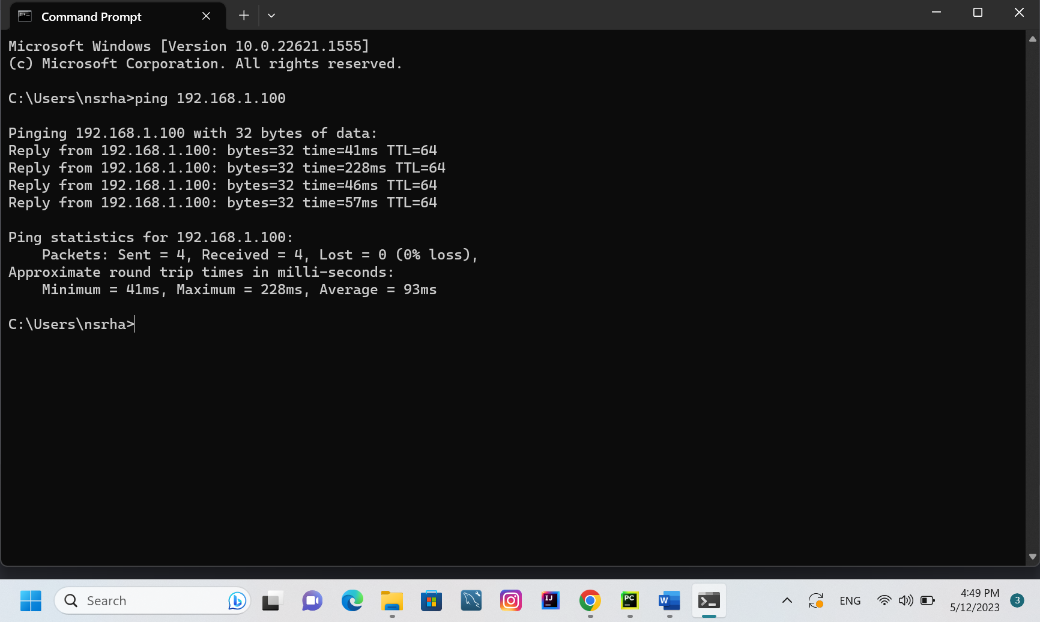

Explain:

The ping command sends a small packet of data to the device and waits for a response, measuring the time it takes for the packet to be sent and received.

The output in this scenario demonstrates that four packets were delivered and received without any loss. The minimum, maximum, and average round trip times are also supplied, indicating how long it takes to send and receive each packet. The round-trip times can indicate the network connection speed and latency between your computer and the device with the IP address 192.168.1.100 (my phone).

2-2) ping www.harvard.edu

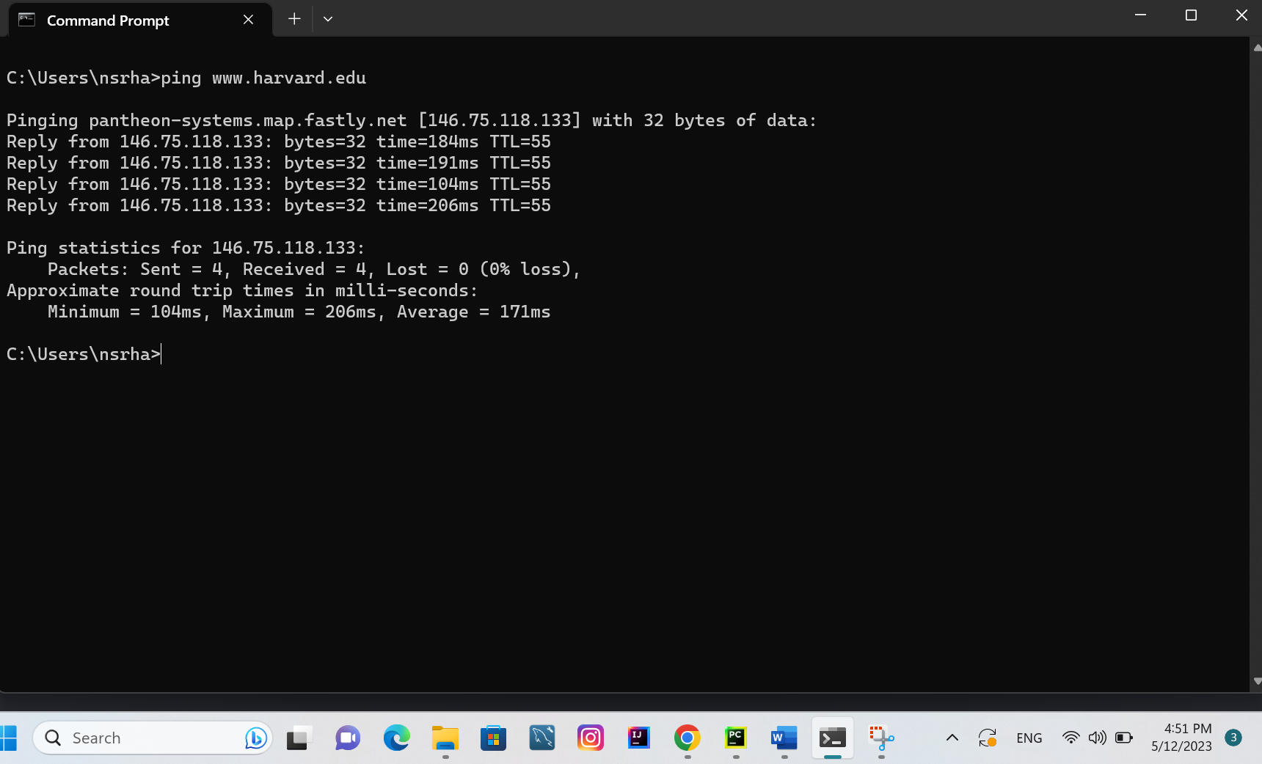

Explain:

The ping command sends packets of data (www.harvard.edu), and then waits for a response. The response time, measured in milliseconds, indicates the time it takes for a packet to travel from the source to the destination and back.

In this case, the ping command was able to successfully send and receive packets from the IP address 146.75.74.133, which is the IP address associated with the hostname pantheon-systems.map.fastly.net that was returned by the nslookup command earlier. The output shows that four packets of data were sent, and all four were successfully received without any packet loss. The round-trip times for the packets ranged from 88ms to 105ms, with an average round trip time of 97ms. This indicates that there is a stable network connection between my computer and the pantheon-systems.map.fastly.net server, which is hosting the www.harvard.edu website.

**2-3) tracert www.harvard.edu**

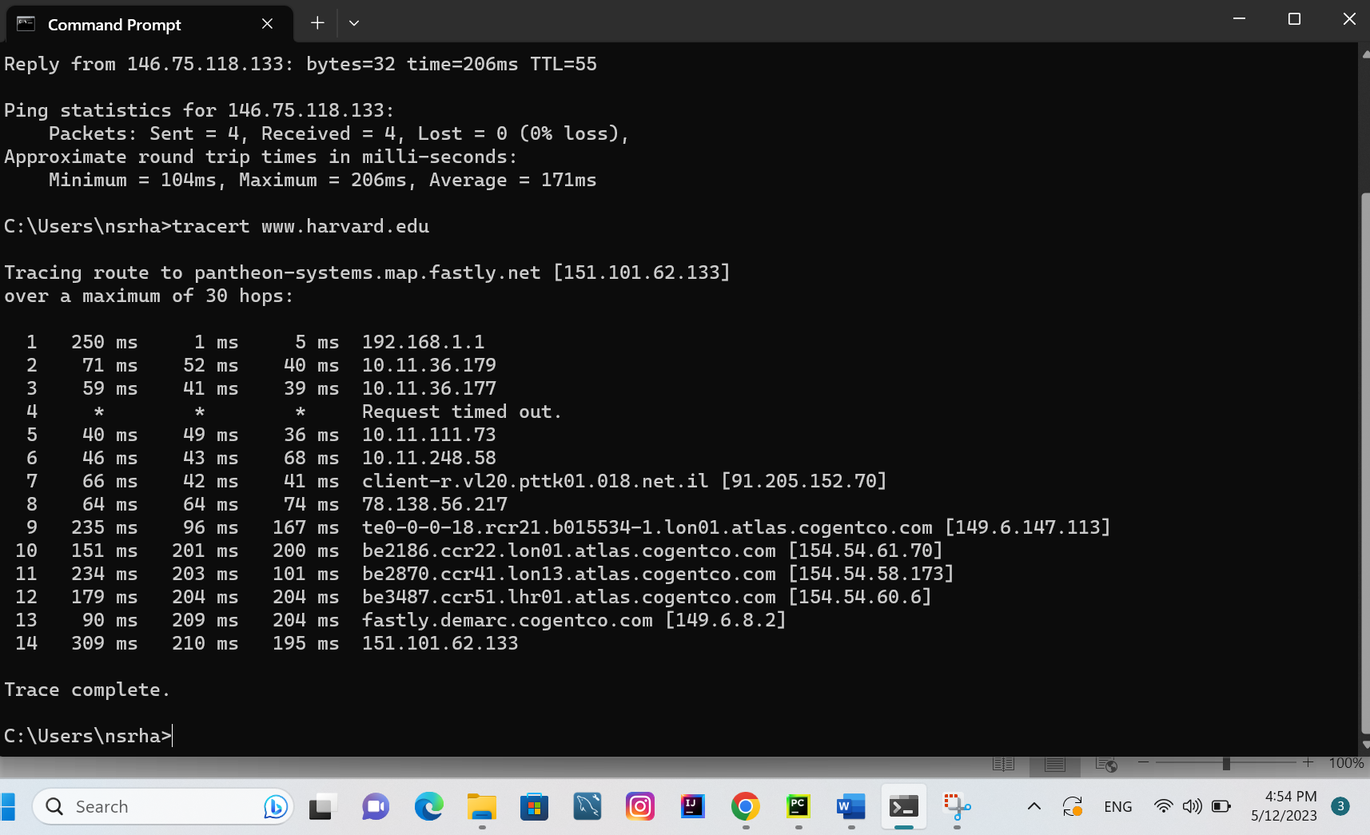

Explanation:

The tracert command is used to track the network path taken by packets from a device to a destination network. In this case, you traced the route from my device to the www.harvard.edu website and it looks like the packets are passing through various routers and network devices to reach the destination.

The output shows the IP addresses of the routers and devices that the packets passed through, along with the time taken by each hop. It also shows that the packets eventually reached the final destination, which in this case is 151.101.62.133 (which is an IP address for the pantheon-systems.map.fastly.net domain that was obtained using nslookup).

**2-4) nslookup** [**www.harvard.edu**](http://www.harvard.edu)

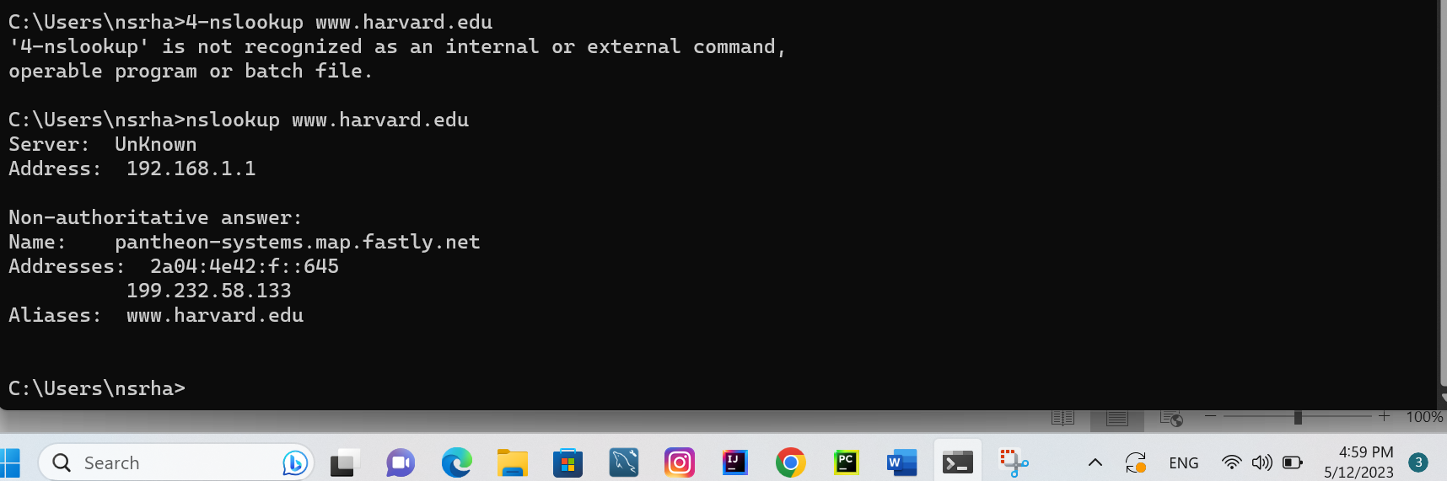

Explanation:

The output of the nslookup command shows that the hostname "www.harvard.edu" resolves to the IP address "199.232.58.133", which is an address assigned to the domain name "pantheon-systems.map.fastly.net". This means that when I type "www.harvard.edu" in my web browser, the browser will connect to the IP address "199.232.58.133" to access the Harvard website.

The "Non-authoritative answer" line in the output indicates that the DNS server that responded to my Snslookup request is not an authoritative source for the "harvard.edu" domain. Instead, it likely forwarded your request to another DNS server that does have authoritative information for the domain.

# Part 2

## Code implementation and theory:

In this part we used socket programming to implement UDP client and server applications and it used broadcast messages, where we used python and socket library to implement it, where for the server code implementation is followed:

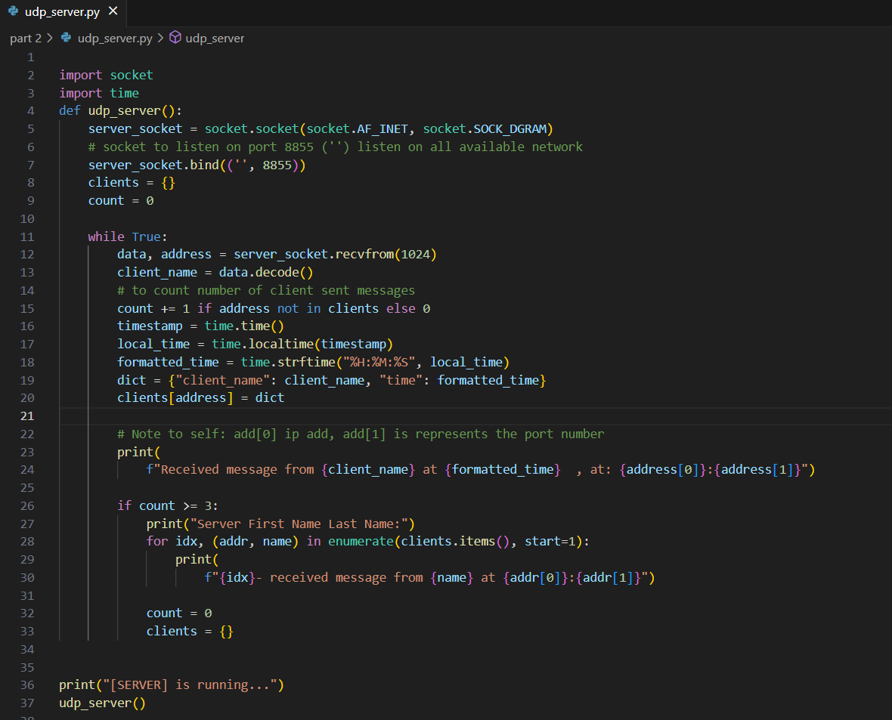

Figure ‎0‑1 UDP Server implementation

And for a UDP client the code implementation is demonstrated in the picture bellow:

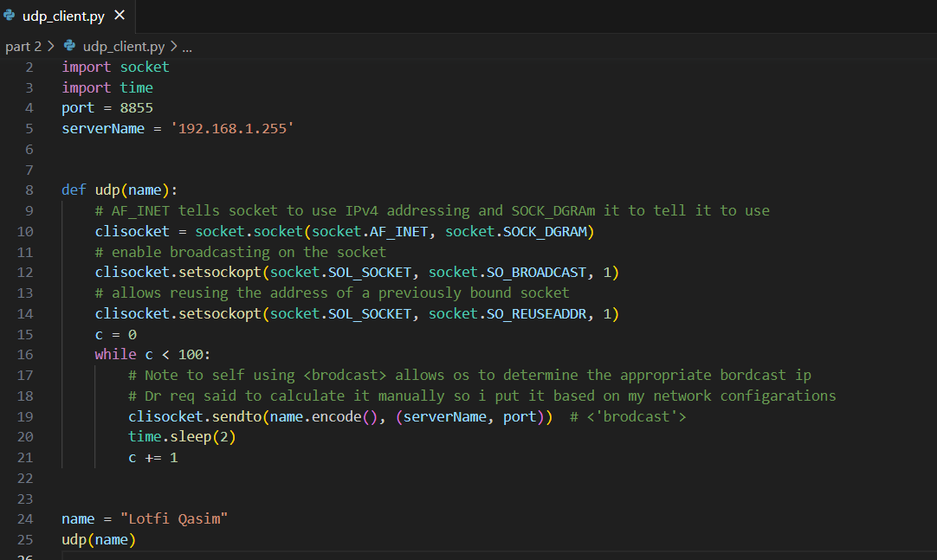

Figure2.2‑‎0‑2 UDP client

Where using client server applications we made the server listen on port 8855, and the client sends broadcast messages for the server with 2seconds sleep time between each message.

## **Code running demonstration:**

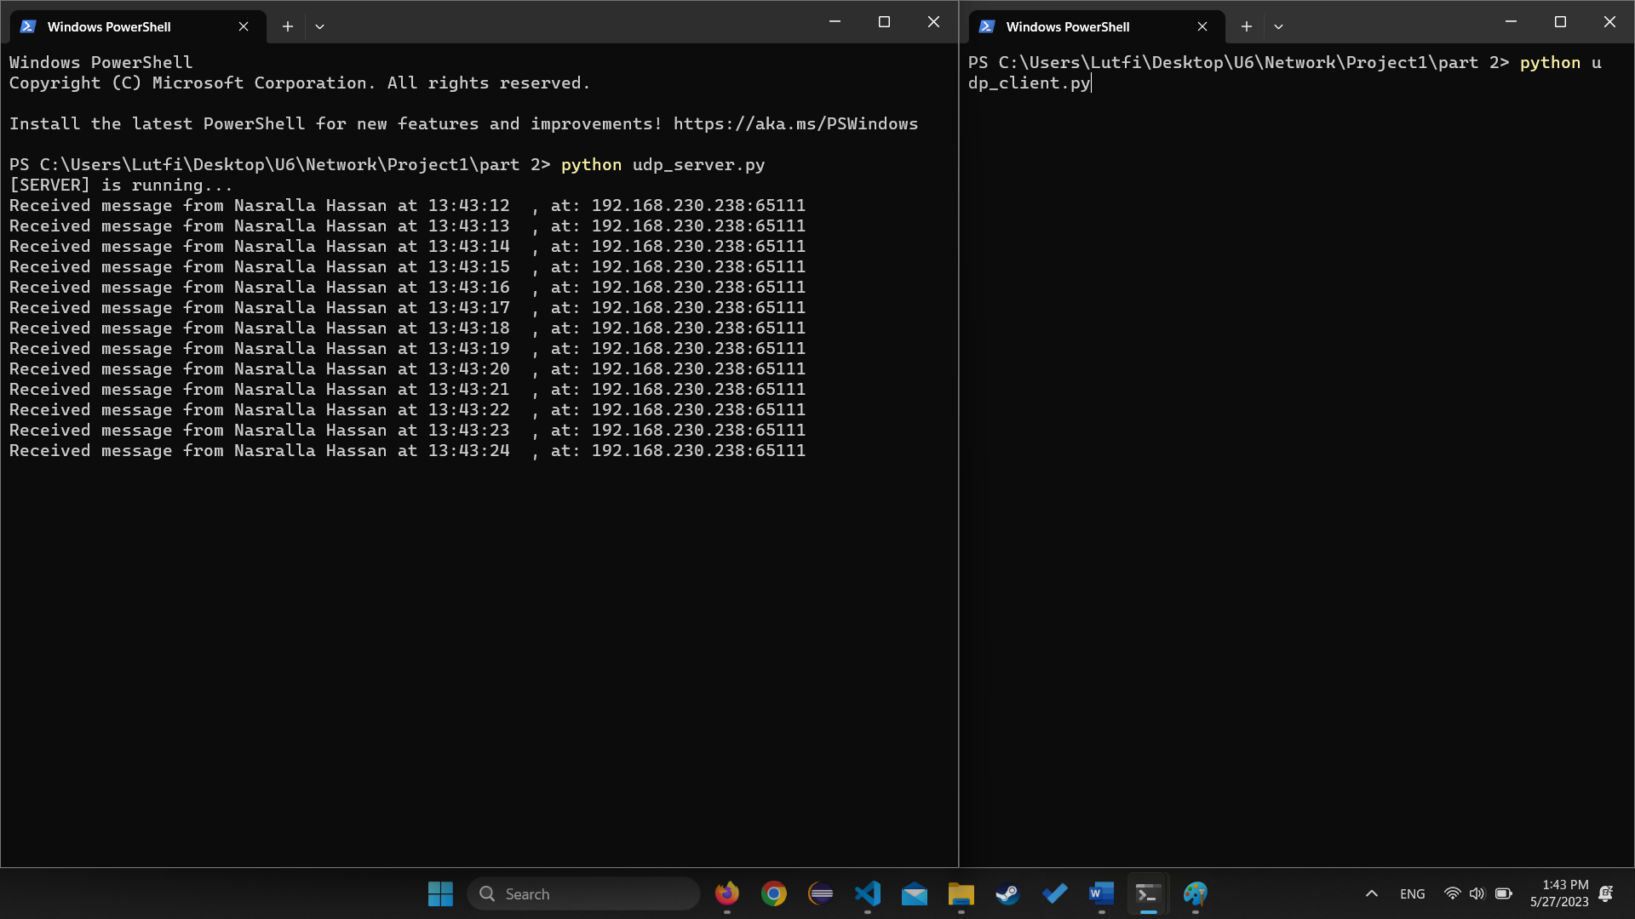

Figure ‎0‑3broadcasting from one device

Figure 3 above demonstrates the activity of the UDP SERVER when a client starts broadcasting data to it from a different device where the UDP SERVER was running and waiting for a broadcast to be initialized with it.

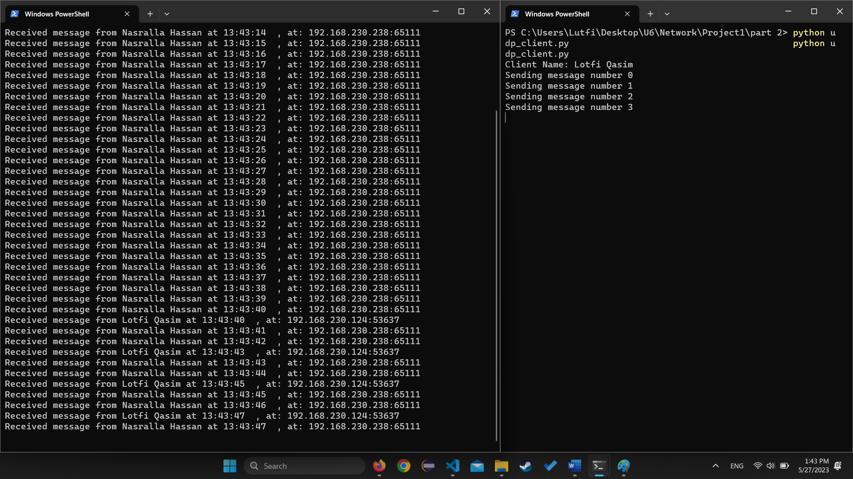

Figure ‑‎0‑4: broadcasting from 2 devices

Figure 4 above shows how the UDP SERVER reacts to it being sent data from more than one client at the same time where it received data from client Lutfi and at the same time was still receiving data from the first client as shown in the figure where the IP address of Nasrallah which is 192.168.230.238: sent opened a socket at port:65111, while IP address of Lutfi which is 192.168.230.124: opened a socket at port: 53637, to the same UDP server which receives at port 8855.

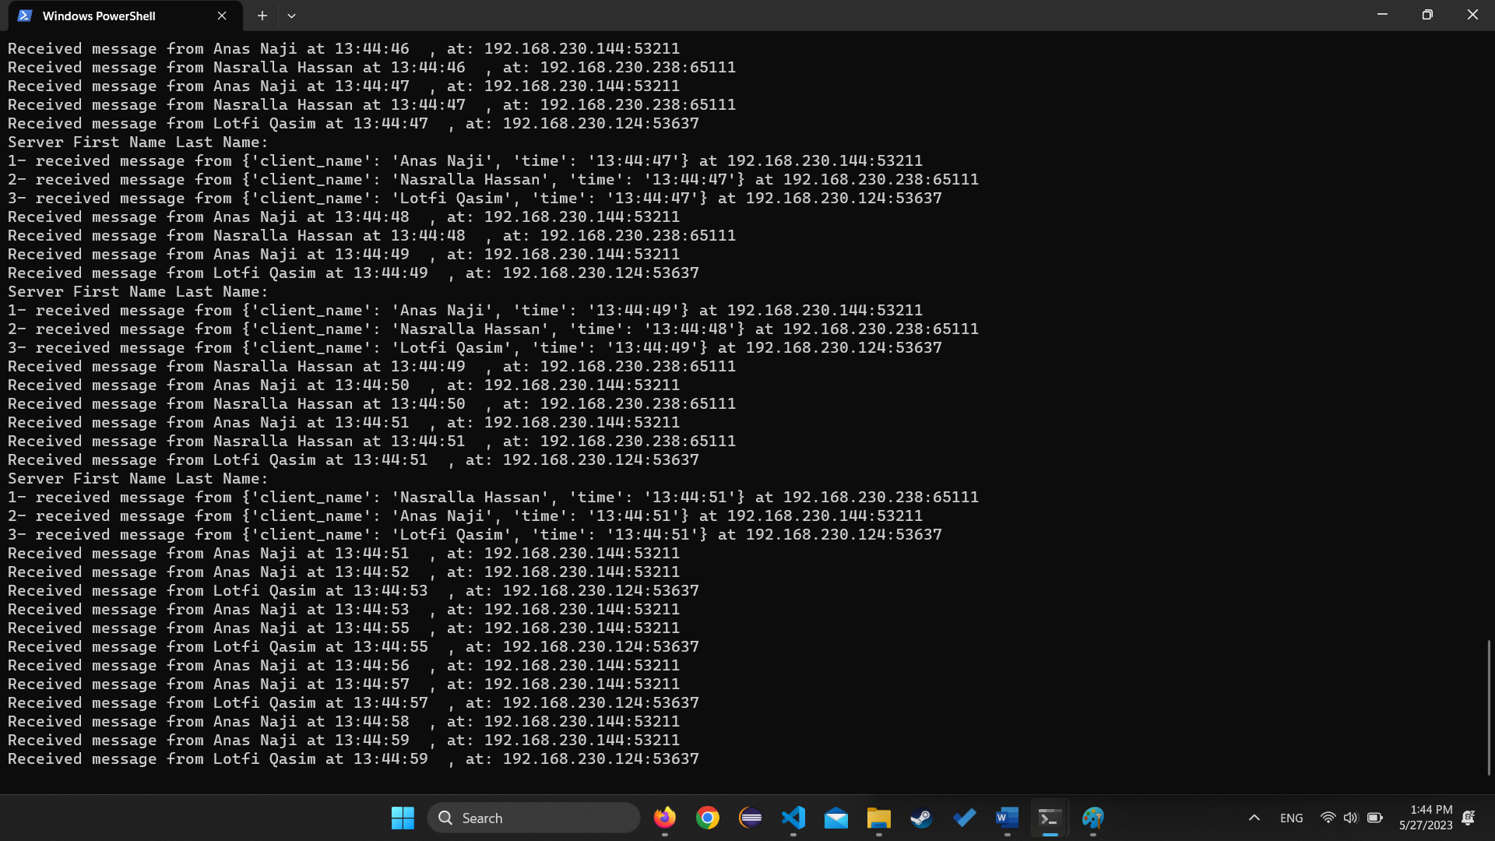

Figure ‎0‑5Broadcasting 3 devices

And as figure 3 shows how the server acts when it receives data from 3 different devices where it shows them as:

1. Received message from {client name:” client name”, time: “time of receive”} at IP address: PORT
2. Received message from {client name:” client name”, time: “time of receive”} at IP address: PORT
3. Received message from {client name:” client name”, time: “time of receive”} at IP address: PORT

# Part 3

## Code Implementation and theory:

In this part we took a different protocol than we did in the second part where we used TCP instead of UDP, and we implemented a simple web server, where it takes HTTP requests at ( localhost:9977/) and gives the appropriate response where it handles requests like <http://localhost:9977/en> where it return the main index page, or <http://localhost:9977/en>, where it return an Arabic format of the main index, and it handles redirect requests to different websites such as YouTube with the following header: <http://localhost:9977/yt>, with a response code 307 Temporary Redirect, and much more websites as was required in the requirements, it handles false requests and not found requests with the appropriate response codes.

### Code implementation:

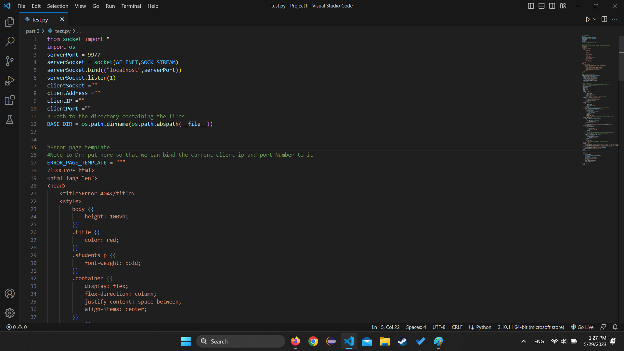

Figure ‎0‑1 Code snippet 1

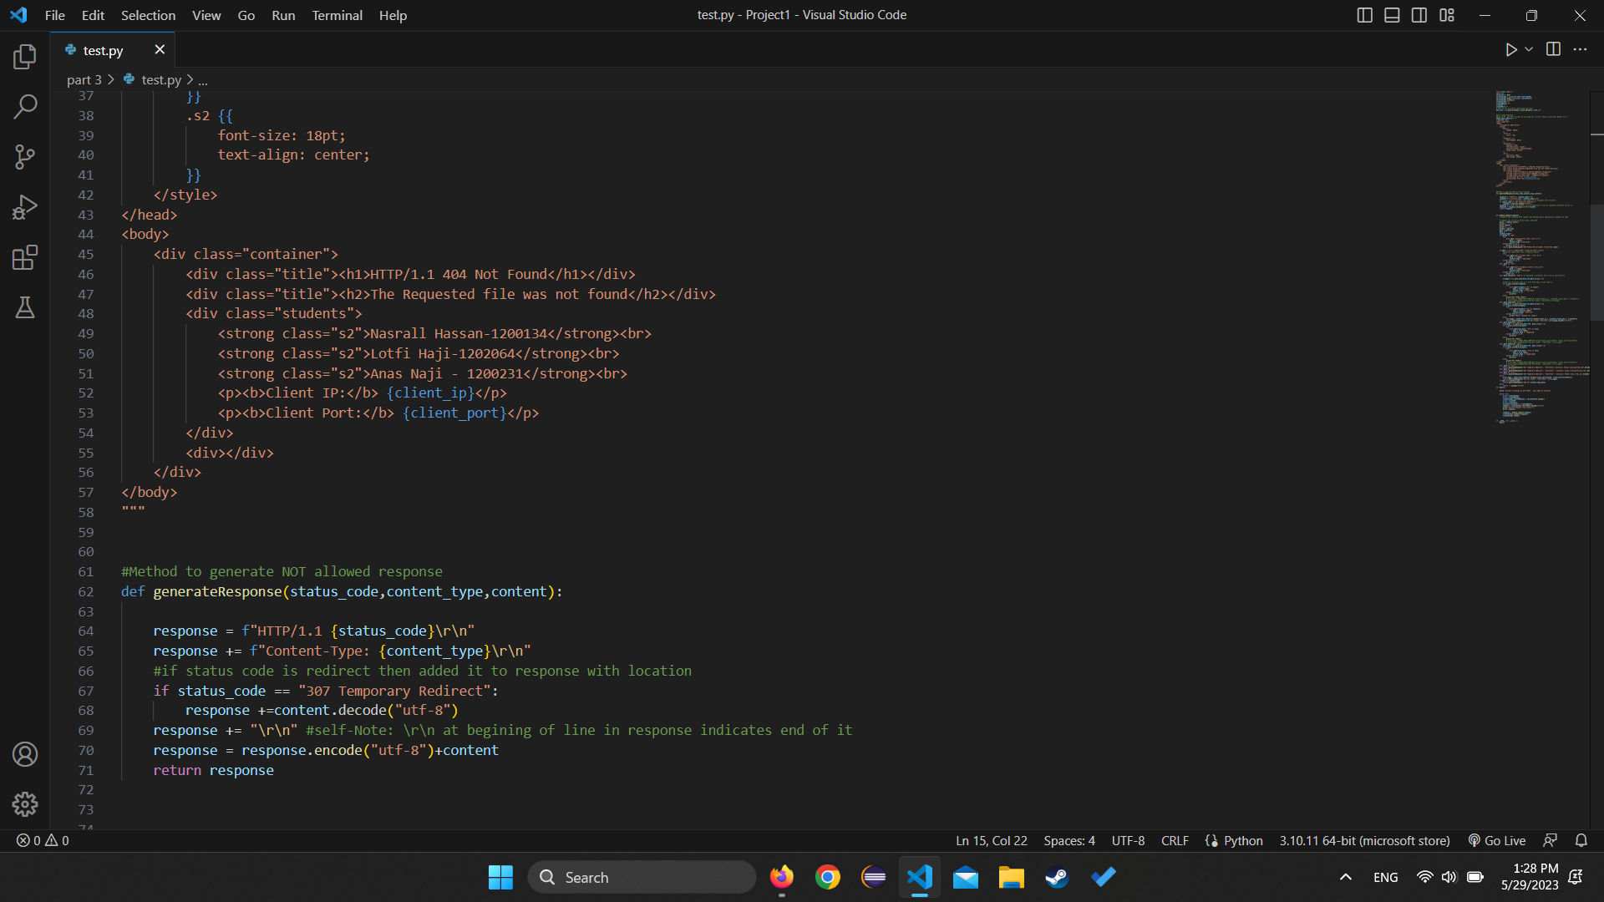

Figure ‎0‑2Code snippet 2

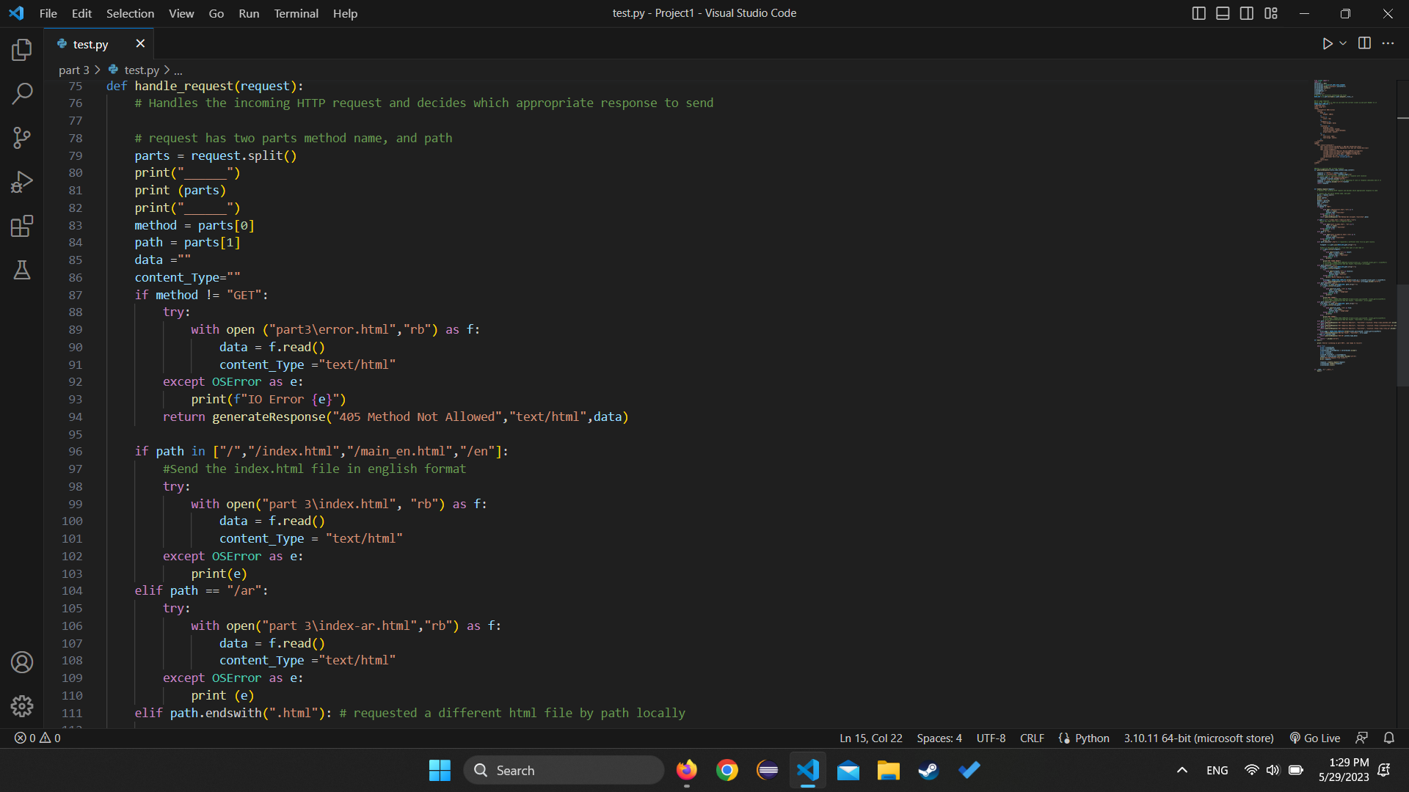

Figure ‎0‑3Code snippet 3

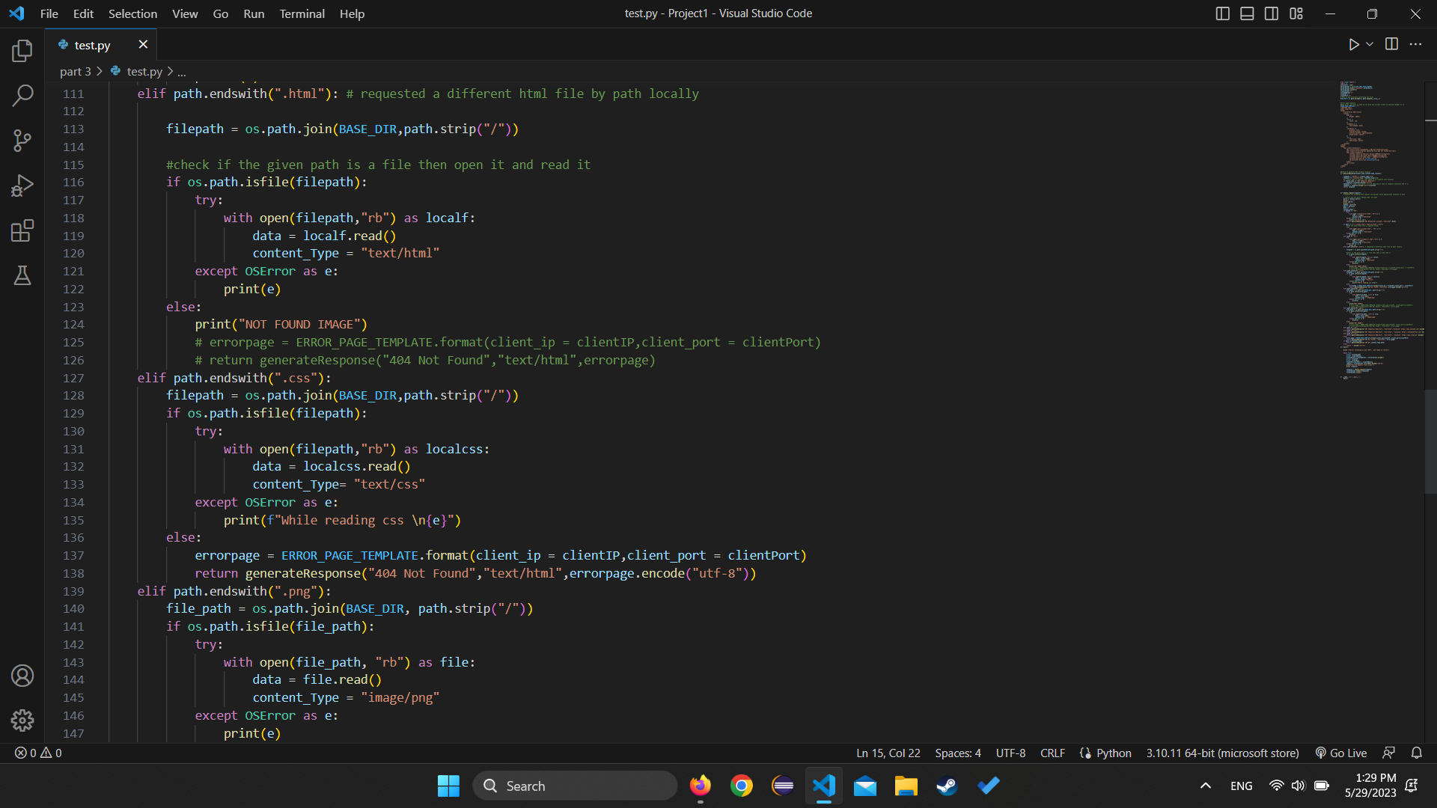

Figure ‎0‑4 Code snippet 4

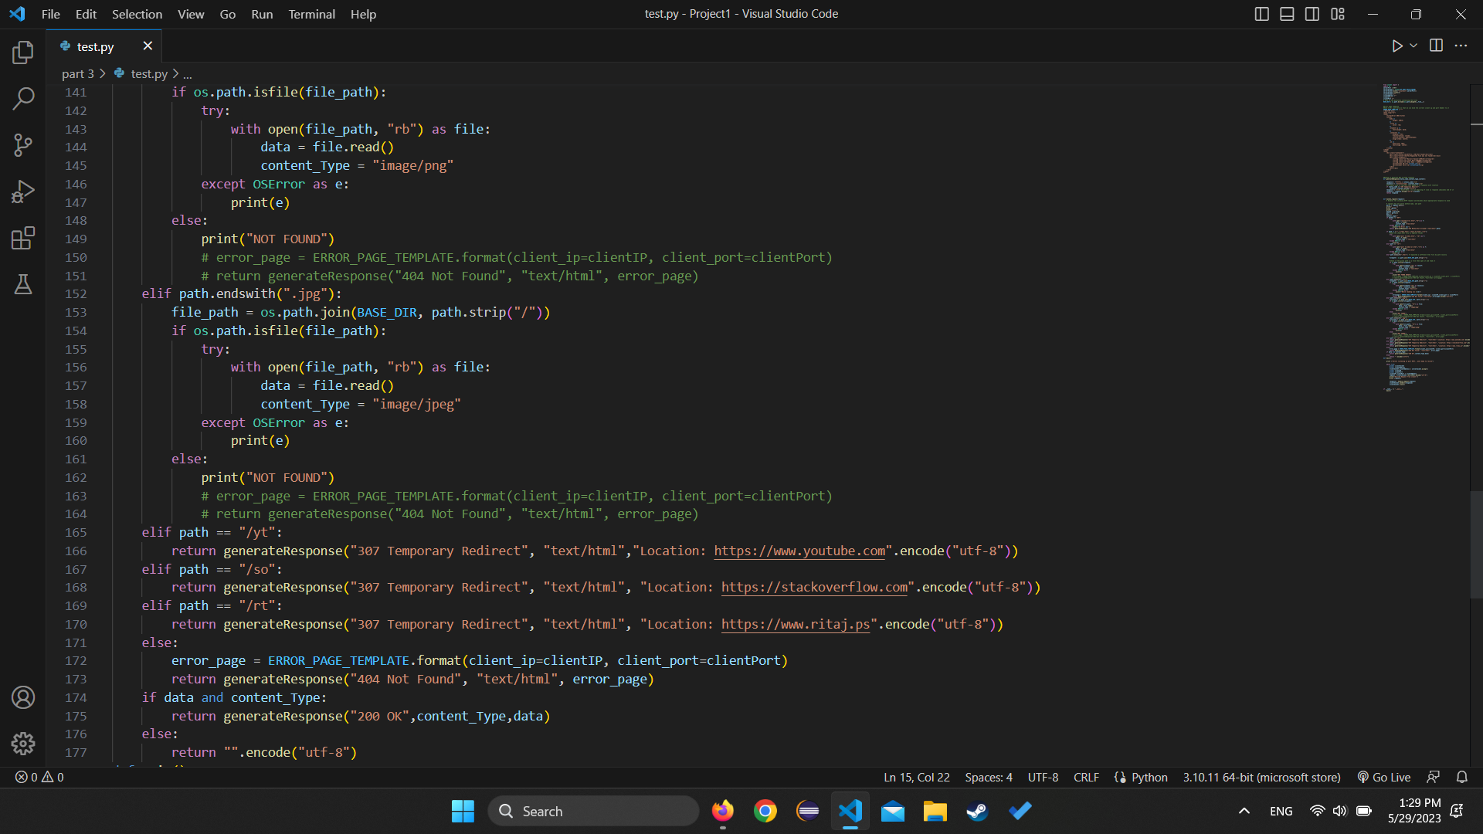

Figure ‎0‑5Code snippet 5

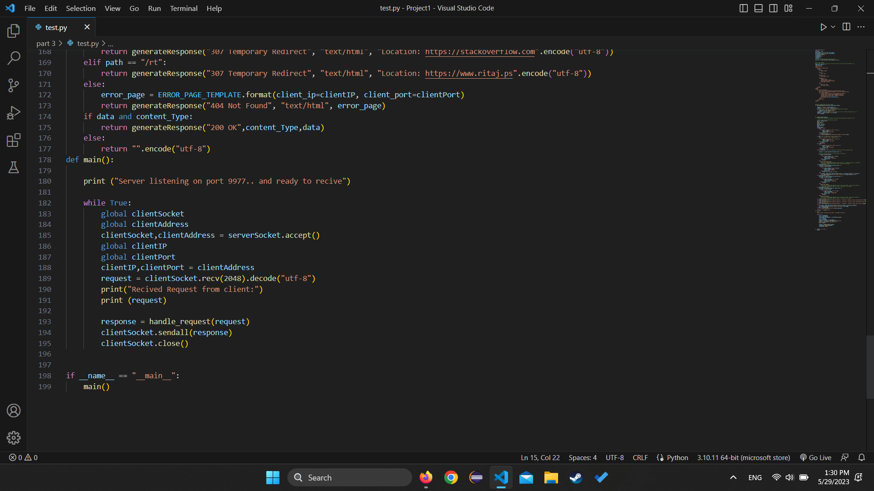

Figure ‎0‑6 Code snippet 6

Where the above photos demonstrate how we approached the implementation of the web server, in which we used python3 as a backend of the server and we used the socket library presented to us by python.

## Code running and testing:

In this part we implemented the Web Server using TCP protocol as shown in the above figures, and now we demonstrate different phases of its run:

Required running phases:

1. if the request is **/ or /index.html or /main_en.html or /en (for example localhost:9977/ or localhost:9977/en)** then the server should send main_en.html file with Content-Type: text/html.
2. If the request is /ar then the server response with main_ar.html which is an Arabic version of main_en.html
3. if the request is an .**html** file then the server should send the requested html file with Content-Type: text/html. You can use any html file.
4. if the request is a **.css** file then the server should send the requested css file with Content-Type: text/css. You can use any CSS file
5. if the request is a .**png** then the server should send the png image with Content-Type: image/png. You can use any image.
6. if the request is a **.jpg** then the server should send the jpg image with Content-Type: image/jpeg. You can use any image.
7. Use the status code 307 Temporary Redirect to redirect the following
   1. If the request is /yet then redirect to YouTube website
   2. If the request is /so then redirects to stackoverflow.com website
   3. If the request is /rt then redirect to ritaj website
8. If the request is wrong or the file doesn’t exist the server should return a simple HTML webpage that contains (Content-Type: text/html)
9. “HTTP/1.1 404 Not Found” in the response status
10. “Error 404” in the title
11. “The file is not found” in the body in **red**
12. Yournames and IDs in **Bold**
13. The IP and port number of the client
14. The program should print the HTTP requests on the terminal window (command line window).

### Request is / or /index.html or /main_en.html or /en (for example localhost:9977/ or localhost:9977/en)

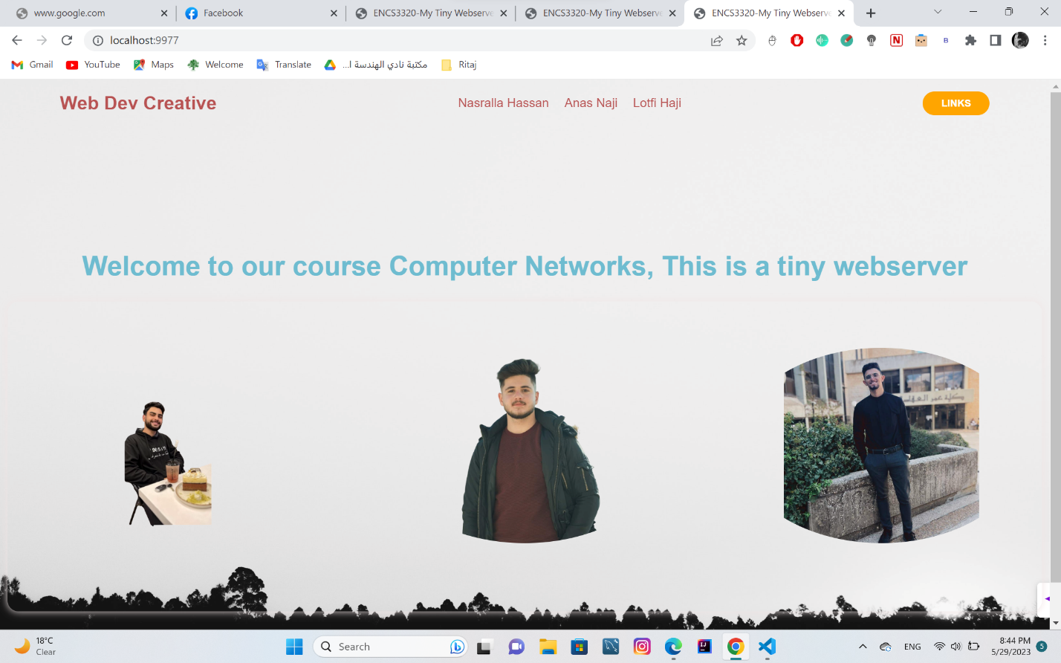

Figure ‎0‑7 main page request

Where when requesting one of the above URLS we end up at the main HTML page written by us, and the HTTP request inside the python terminal for this request is:

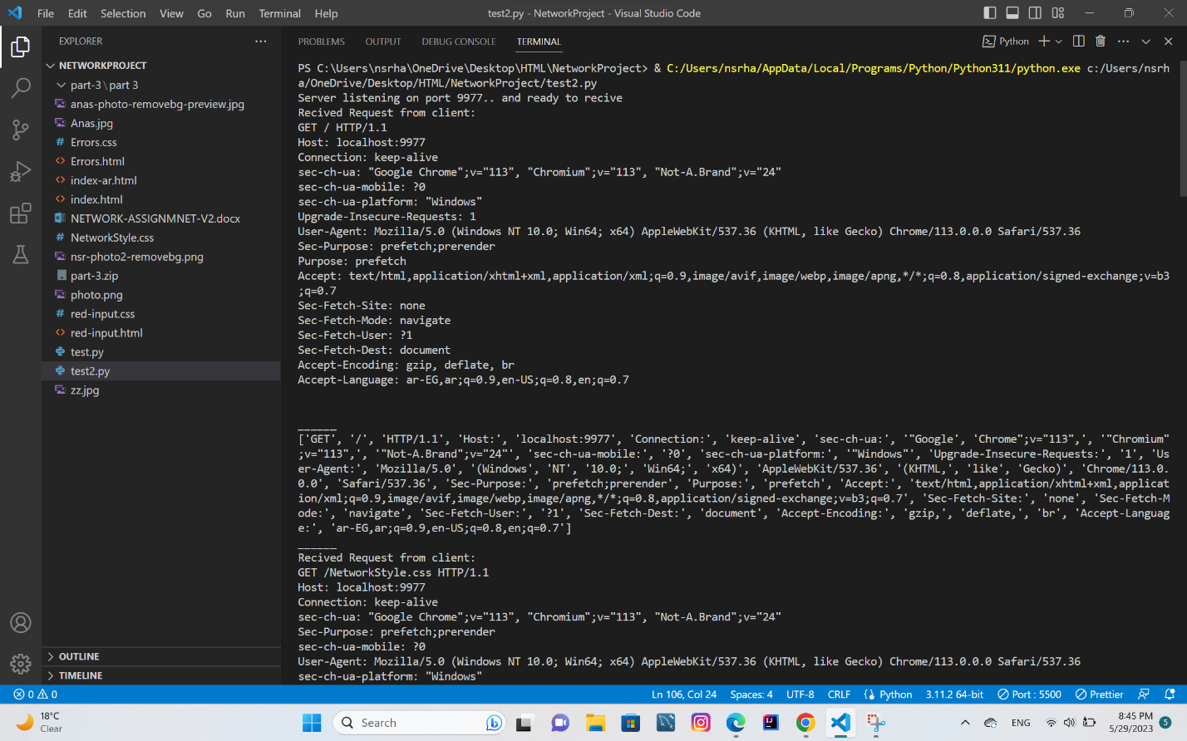

Figure ‎0‑8 first request window

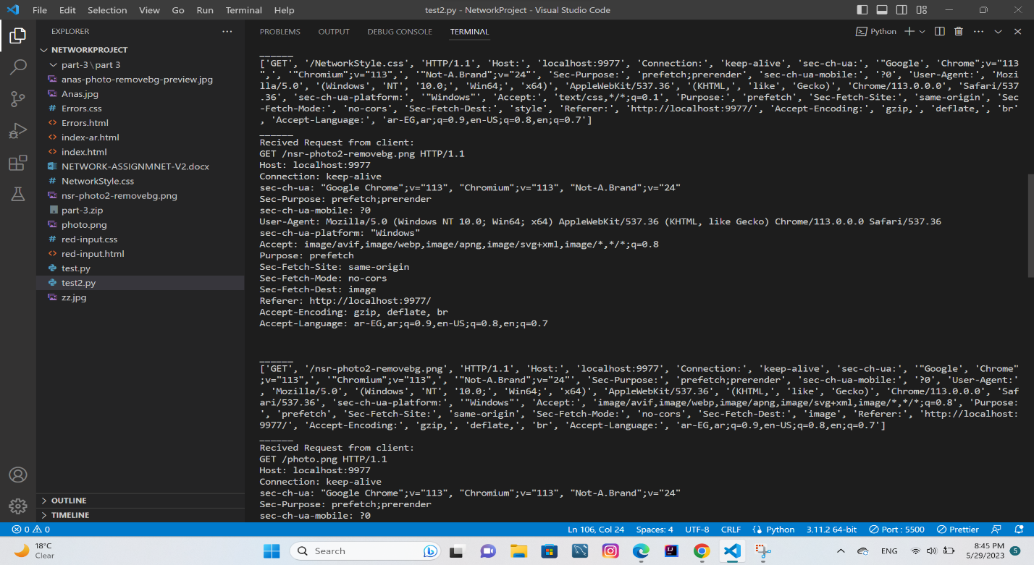

Figure ‎0‑9 Second request window

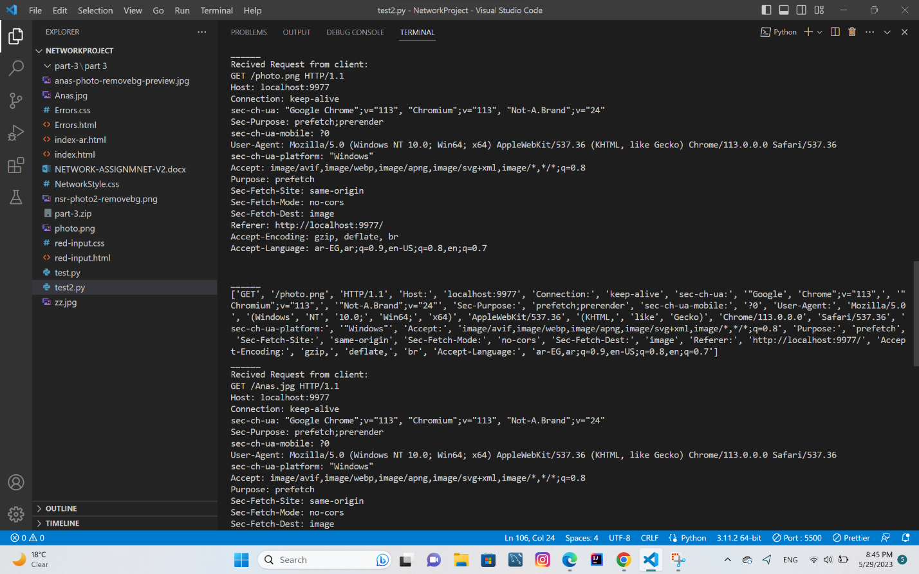

Figure ‎0‑10 third request window

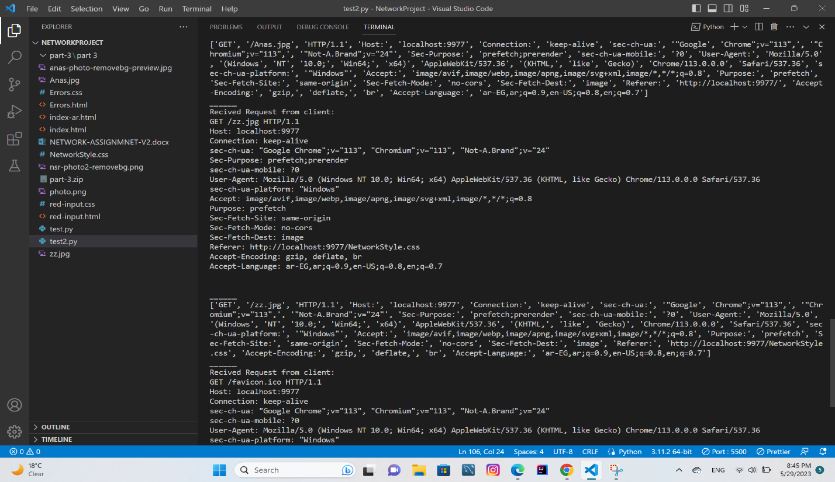

Figure ‎0‑11 fifth request window

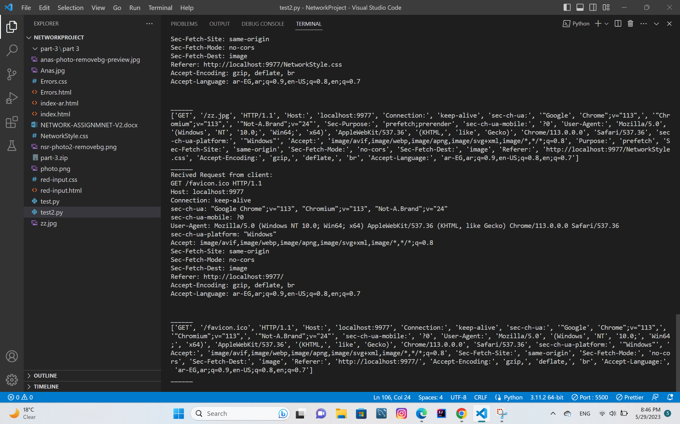

Figure ‎0‑12 sixth request window

And as shown above those are all the requests done by the browser in order to retrieve the main page and then requesting the images, and the CSS file for the that index.html page.

### If the request is /ar then the server response with main_ar.html which is an Arabic version of main_en.html

Here we requested localhost:9977/ar, and we got the following response:

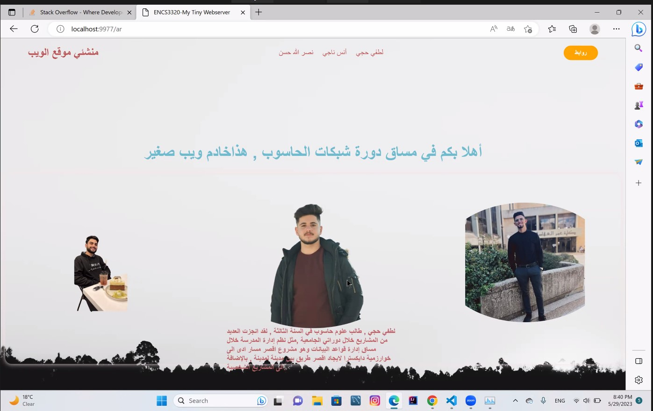

Figure ‎0‑13 Arabic response page

And below are the HTTP requests in the python terminal:

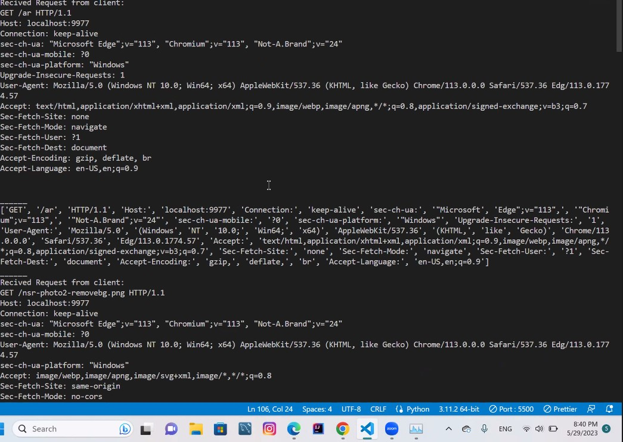

Figure ‎0‑14 Arabic HTTP 1

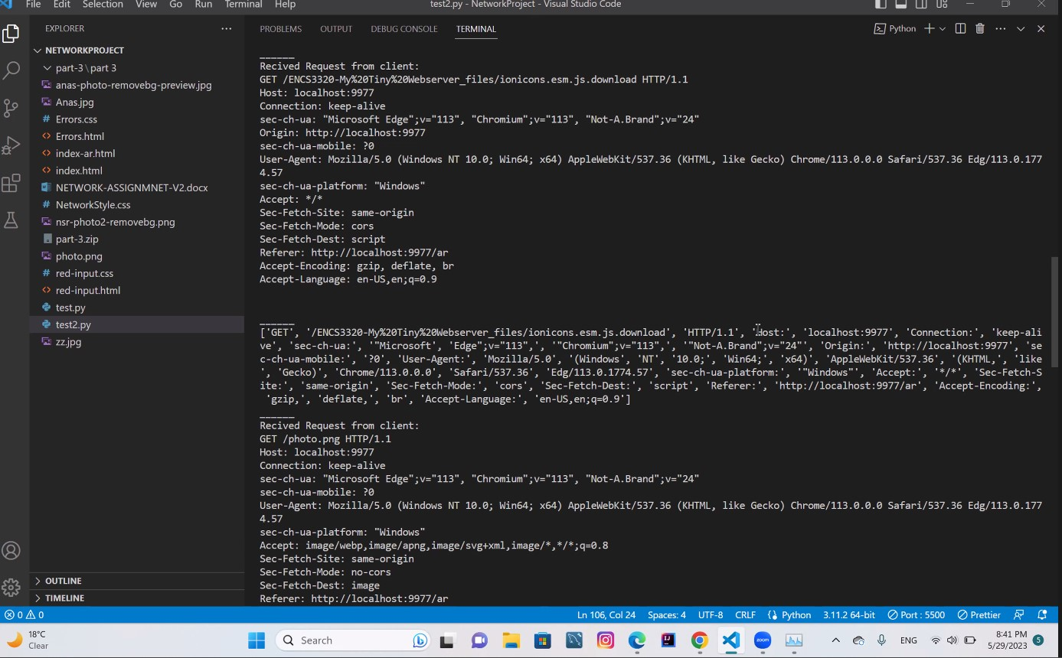

Figure ‎0‑15 Arabic HTTP 2

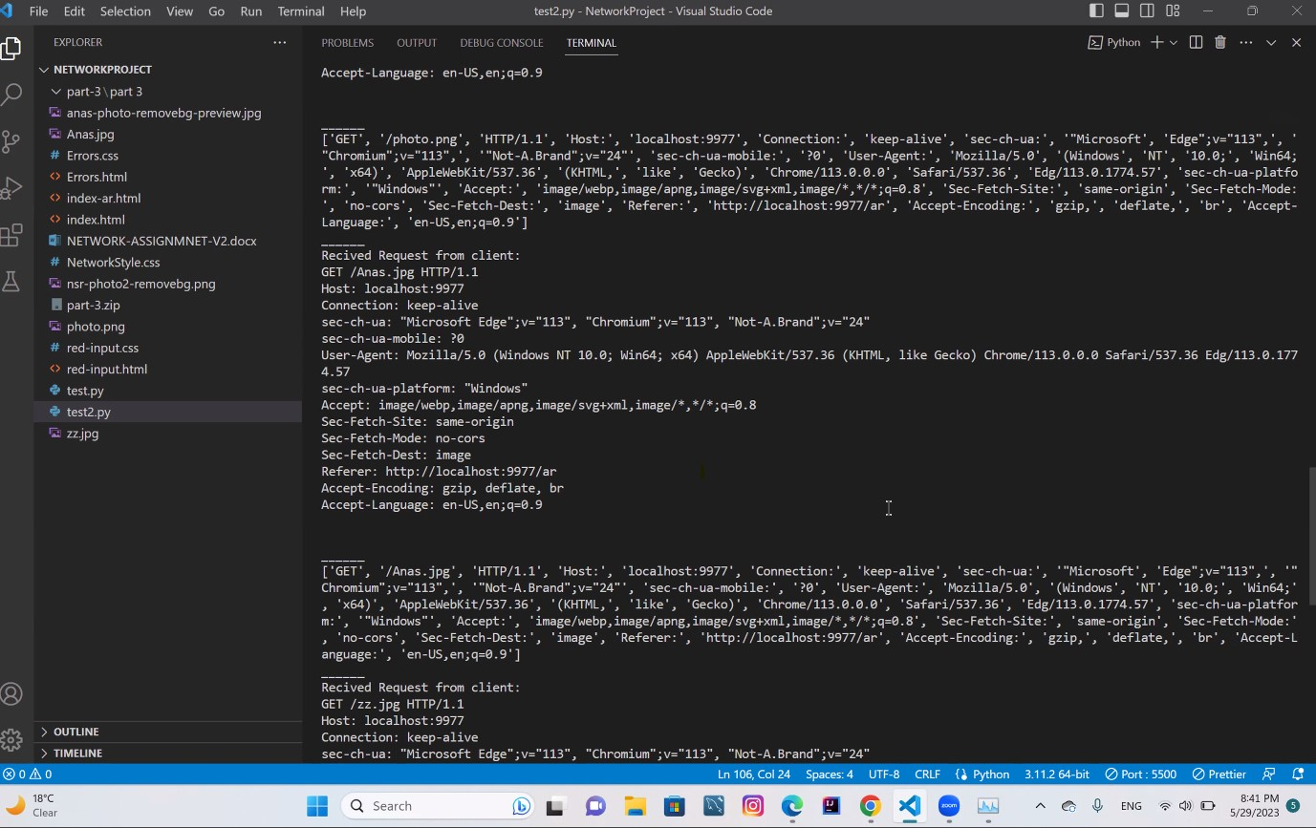

Figure ‎0‑16Arabic HTTP 3

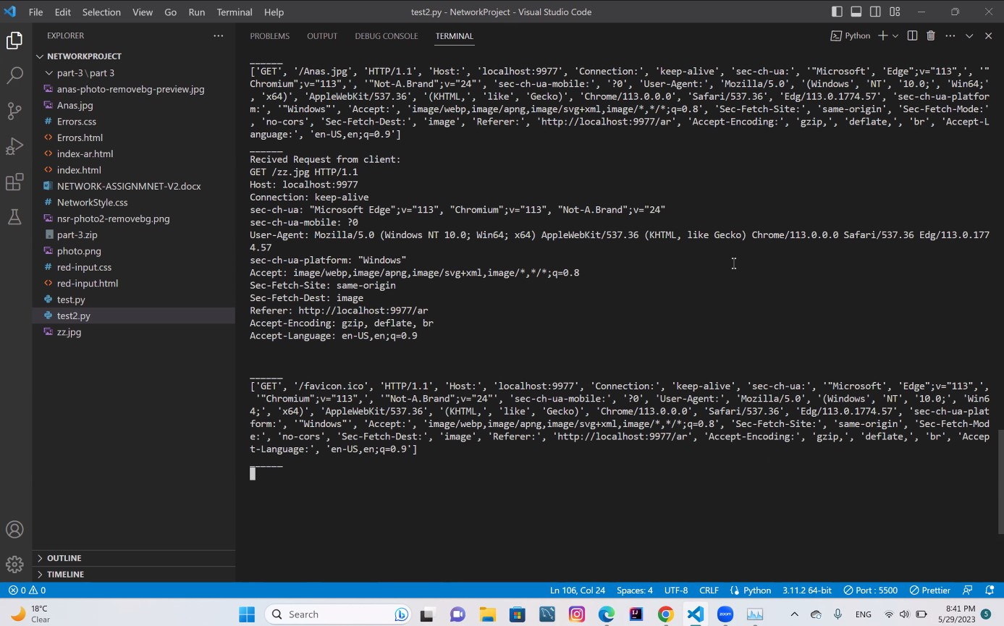

Figure ‎0‑17 Arabic HTTP 4

### if the request is an .html file then the server should send the requested html file with Content-Type: text/html. You can use any html file.

Here we requested a random html page on the local host which name is store.html, and we have got it as a response as the following page, note: this page didn’t have a CSS reference:

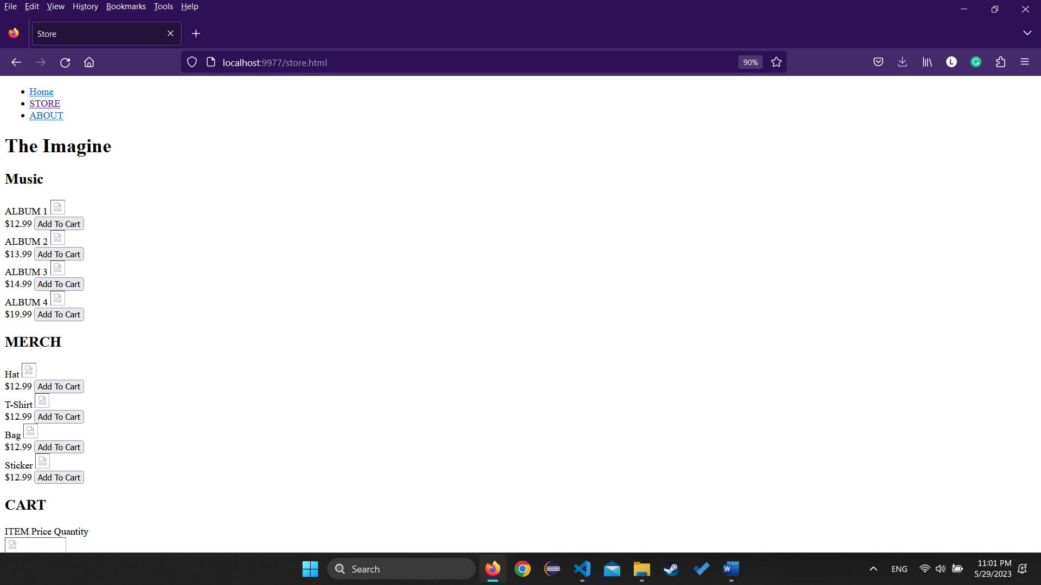

Figure ‎0‑18 Random html page

And here bellow is the HTTP request in the terminal for this request:

### 4-if the request is a .css file then the server should send the requested css file with Content-Type: text/css. You can use any CSS file

Here we have requested a random CSS file from local host and we have gotten the following response:

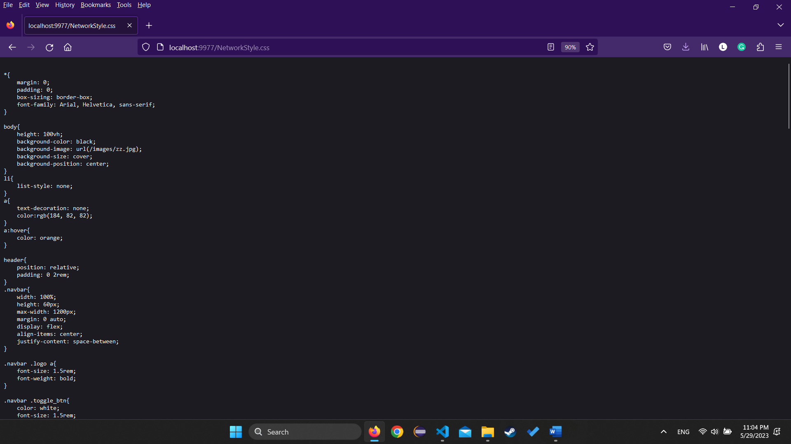

Figure ‎0‑19 CSS REQUEST RESPONSE

And as shown the server has successfully found the requested CSS file and return it as a text/CSS file, and the following HTTP request was given in the terminal:

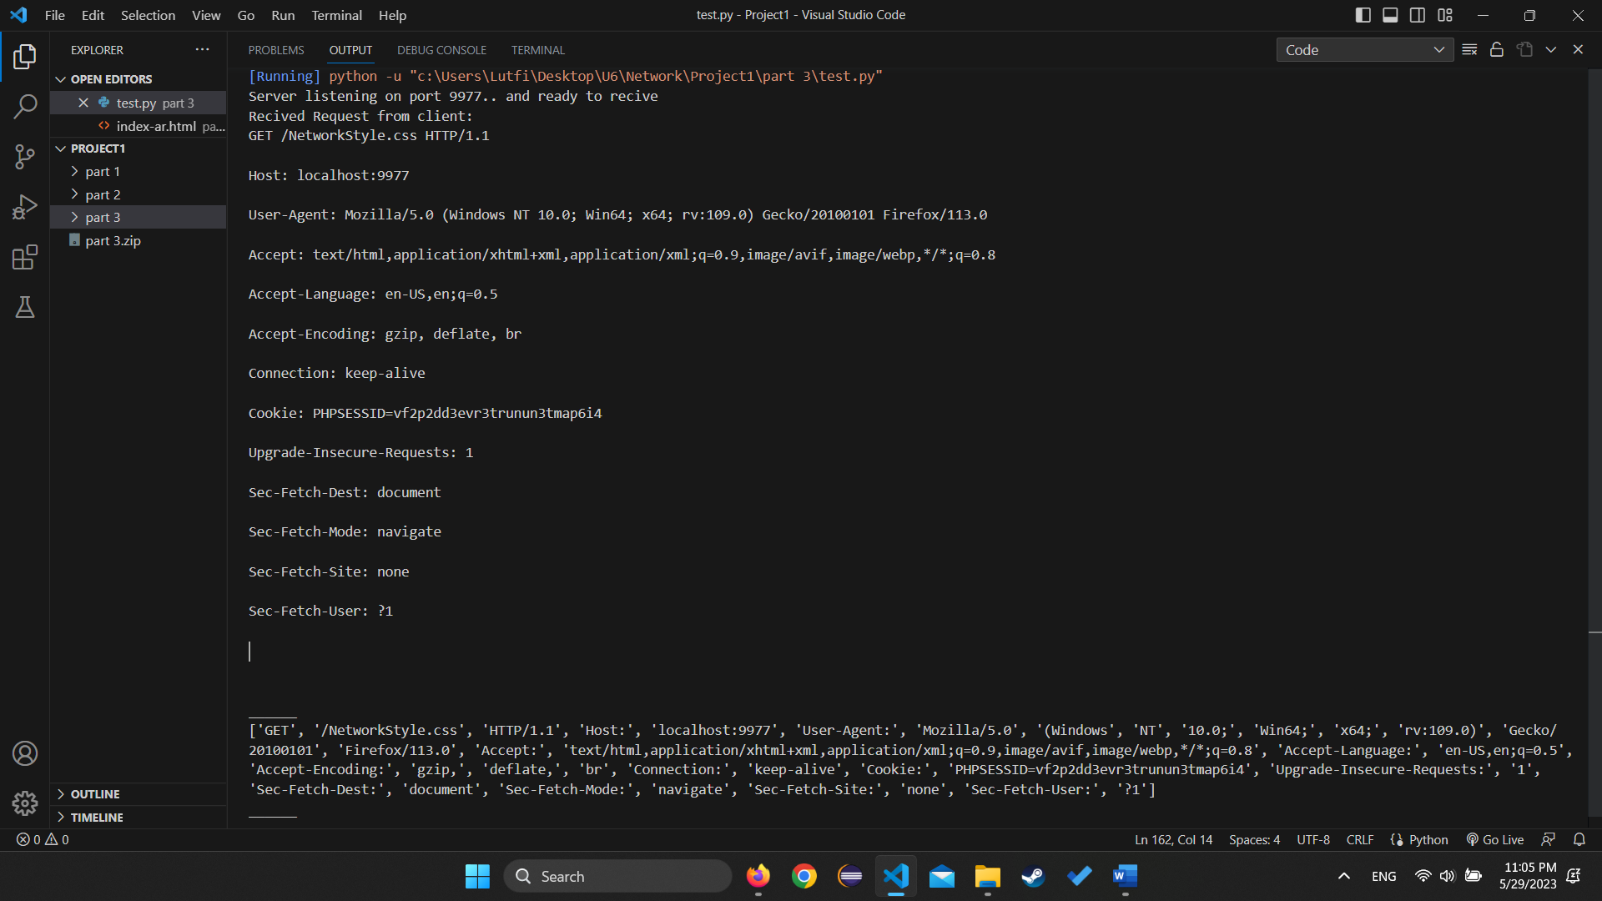

Figure ‎0‑20 CSS HTTP

### if the request is a .png then the server should send the png image with Content-Type: image/png. You can use any image.

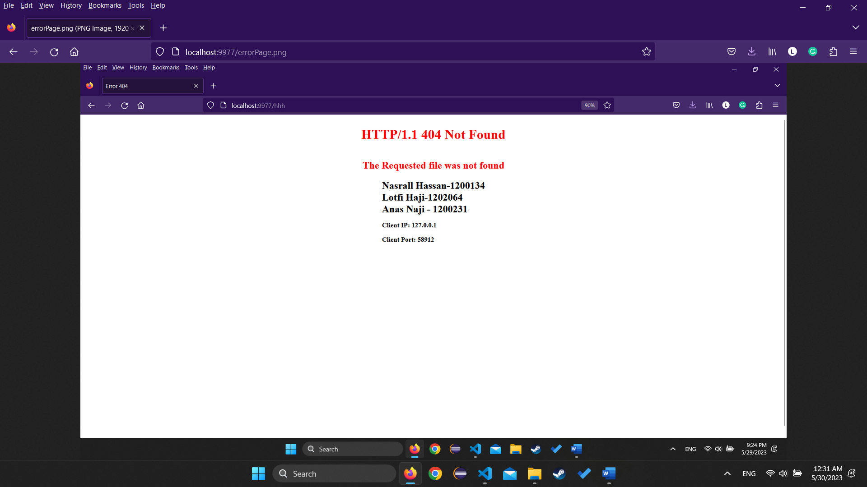

Figure ‎0‑21Request Png

In this segment we have requested a png photo and the results of this request successfully retrieved the photo, the HTTP request in terminal is shown below:

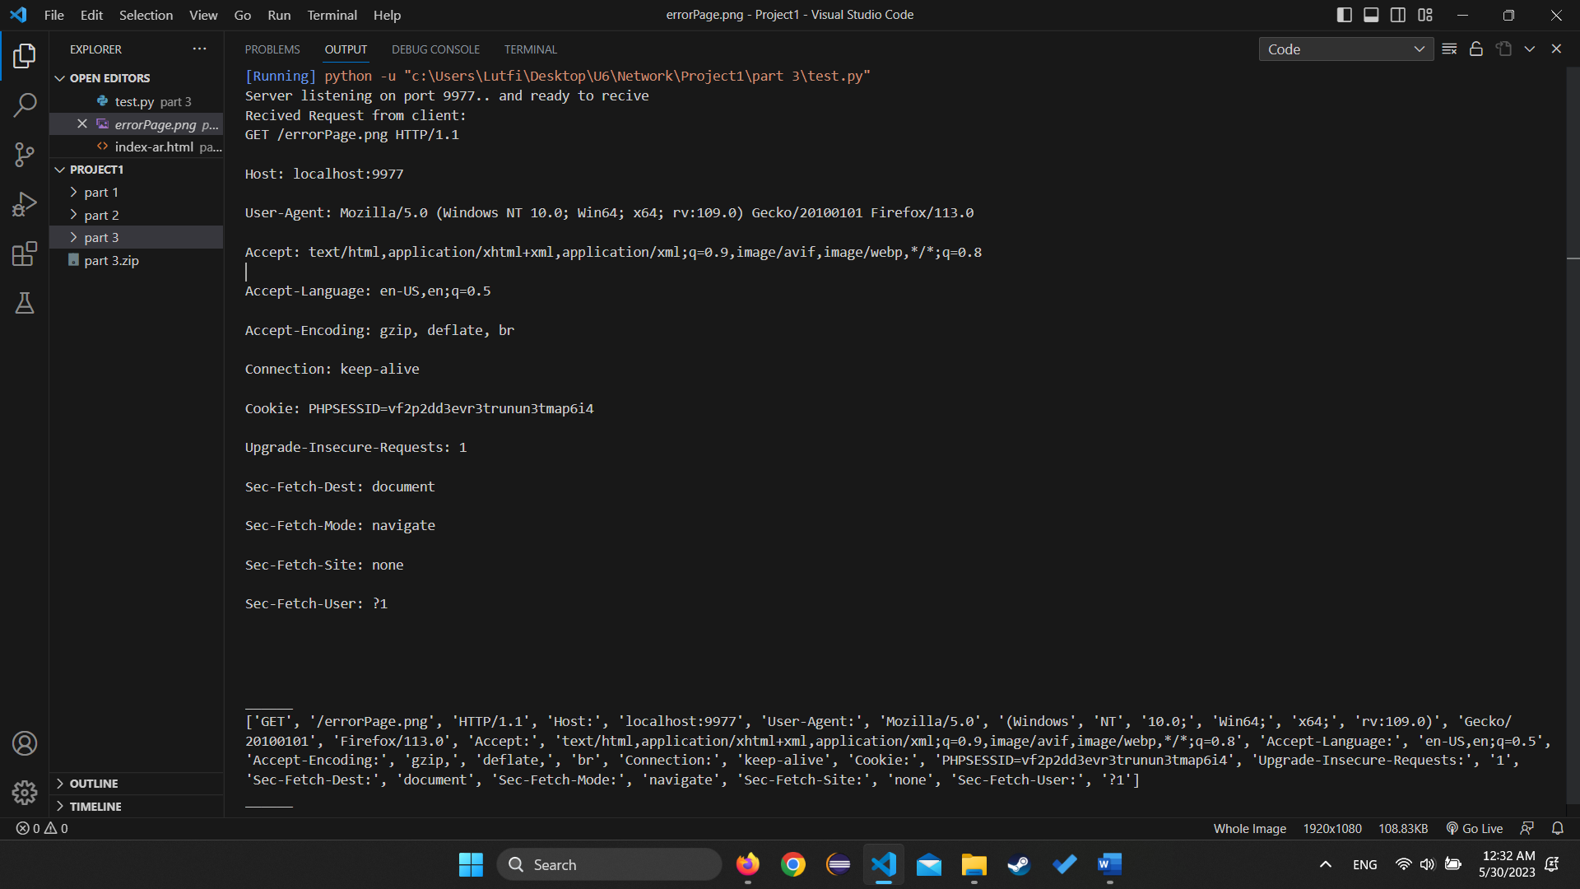

Figure ‎0‑22Request png Terminal

### 6-if the request is a .jpg then the server should send the jpg image with Content-Type: image/jpeg. You can use any image.

In this part we have requested a jpg photo and the response was successful where it retrieved the correct image/jpeg photo as shown below:

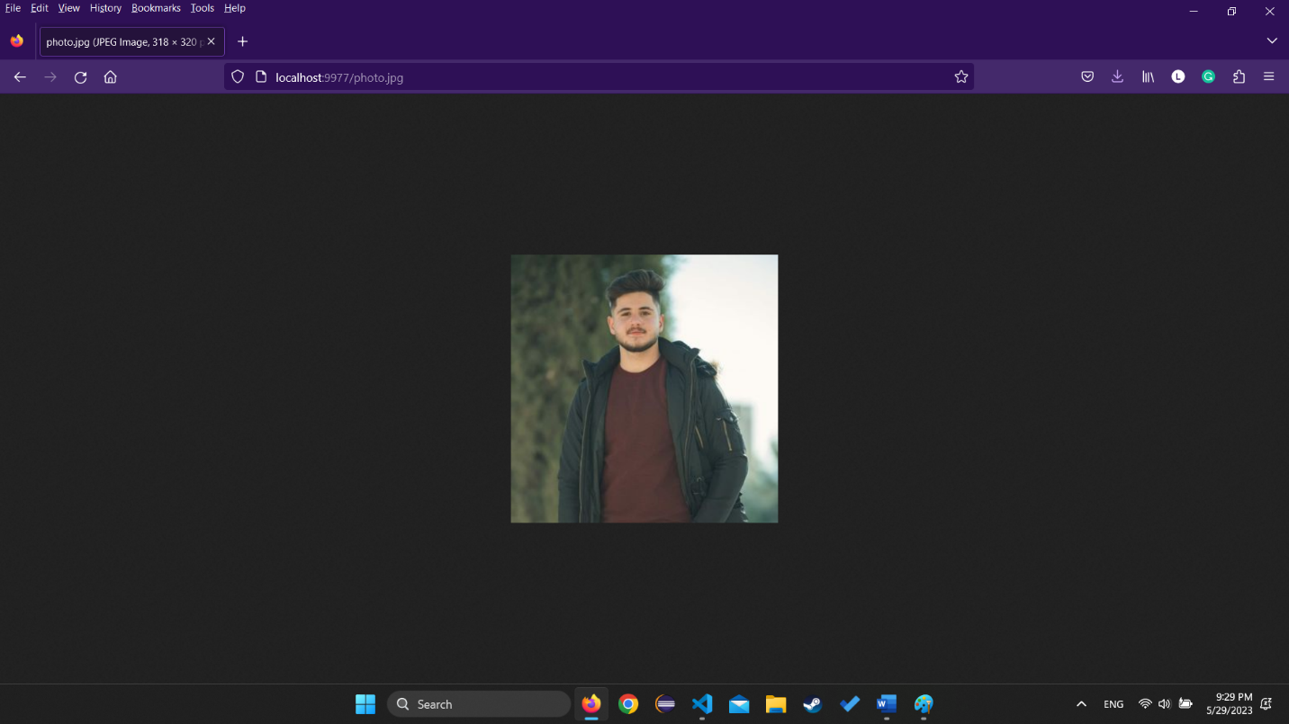

Figure ‎0‑23Jpg photo request

And here is the HTTP request in terminal: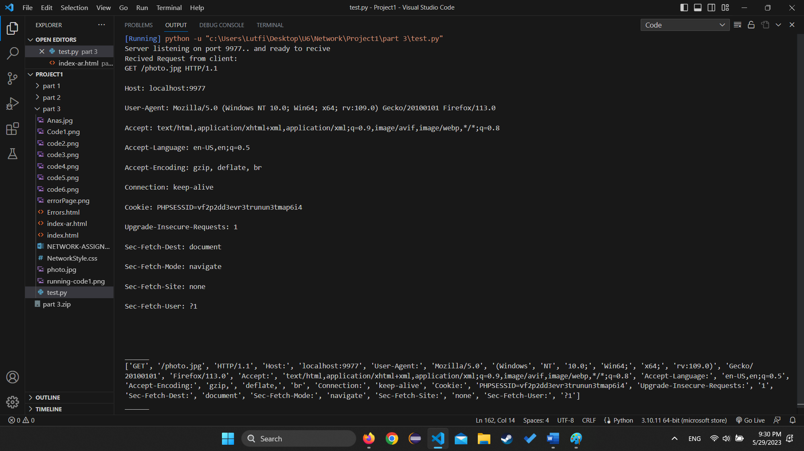

Figure ‎0‑24Terminal jpg

### 7-Use the status code 307 Temporary Redirect to redirect the following

#### If the request is /yt then redirect to YouTube website

And shown below are the URL requested and then the redirection to YOUTUBE page:

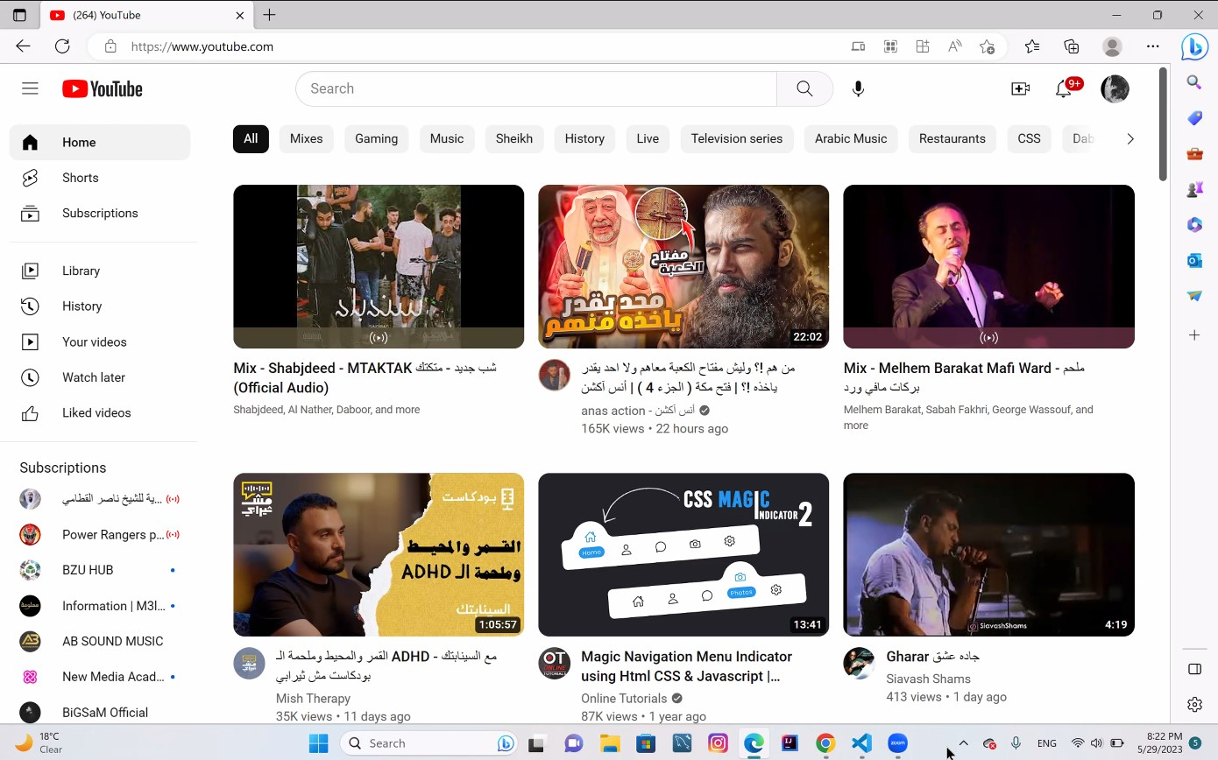

Figure ‎0‑25YouTube redirection:

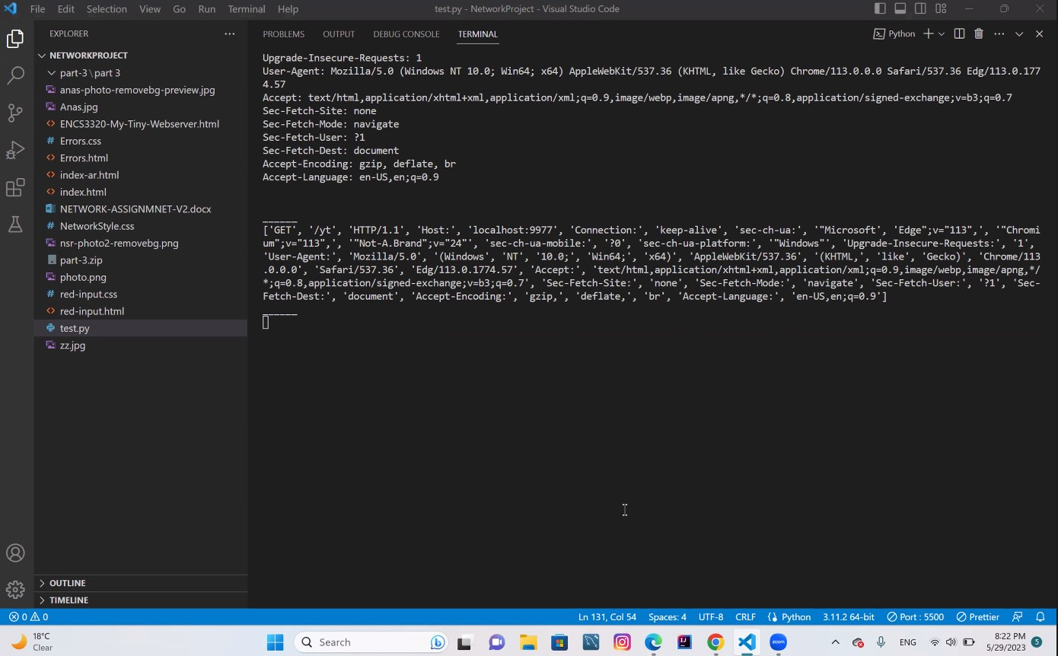

Figure ‎0‑26HTTP request in terminal

#### If the request is /so then redirects to stackoverflow.com website:

And shown below are the URL requested and then the redirection to Stack Overflow page:

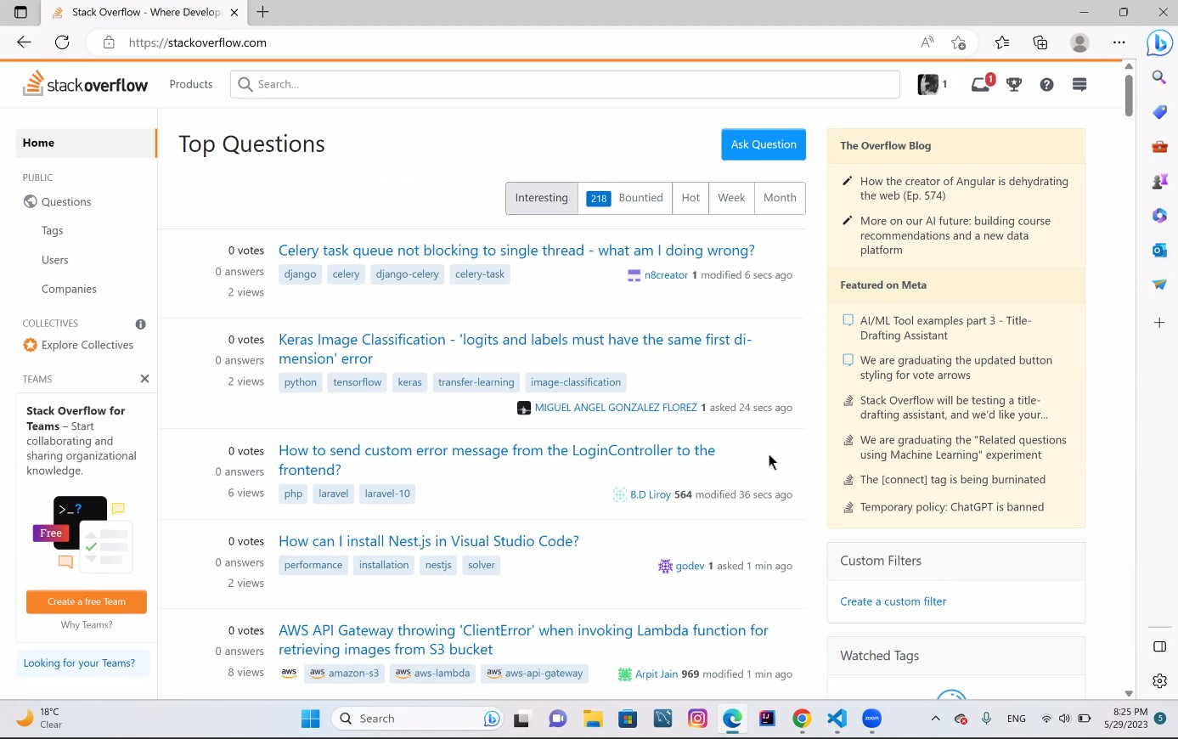

Figure ‎0‑27Stack over flow redirection

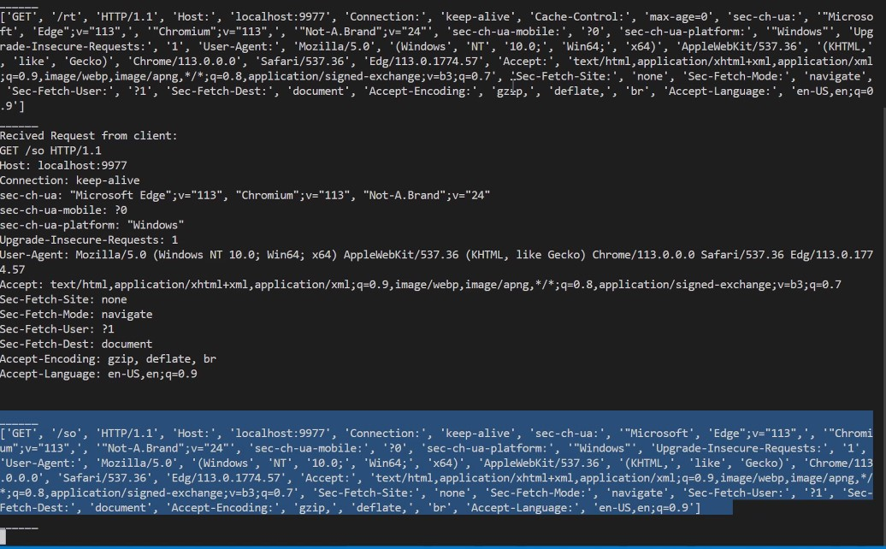

Figure ‎0‑28Stack over flow terminal

#### If the request is /rt then redirect to ritaj website

In this part we couldn’t redirect to ritaj page since it requires a secure connection which we assumed is due to the DoS security program that has been introduced to ritaj recently.

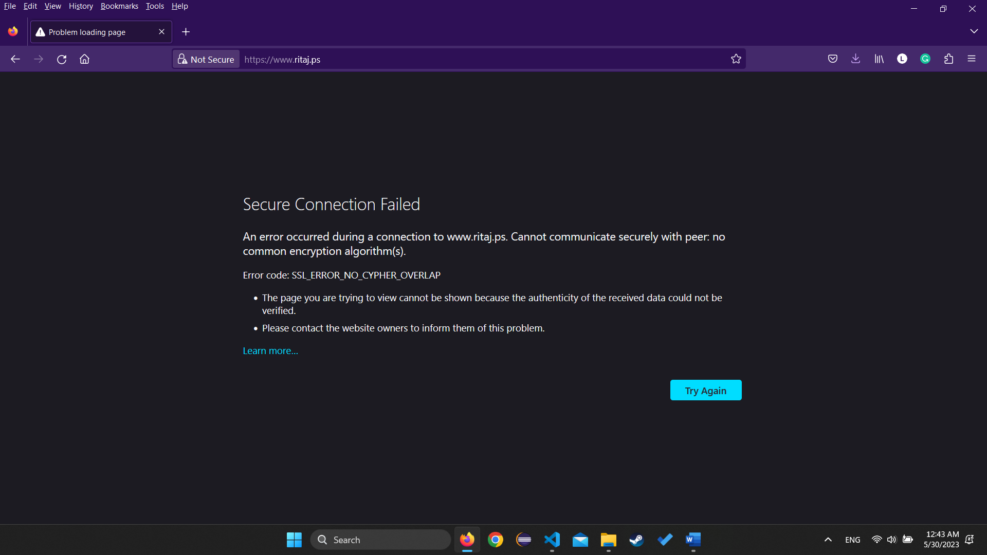

Figure ‎0‑29Tring to access ritaj

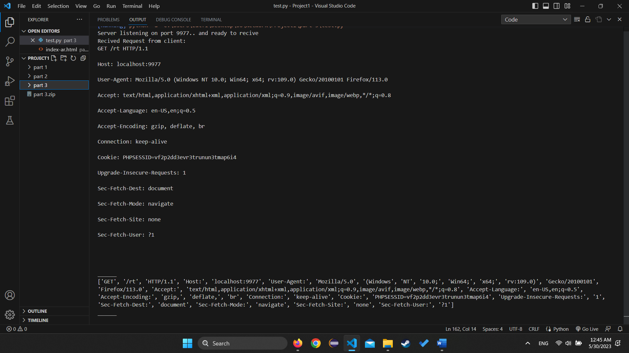

Figure ‎0‑30Terminal for HTTP req on ritaj

### 8- If the request is wrong or the file doesn’t exist the server should return a simple HTML webpage that contains (Content-Type: text/html)

1- “HTTP/1.1 404 Not Found” in the response status

2- “Error 404” in the title

3- “The file is not found” in the body in red

4-Your names and IDs in Bold

5-The IP and port number of the client

And here is the Page that we retrieve after the request:

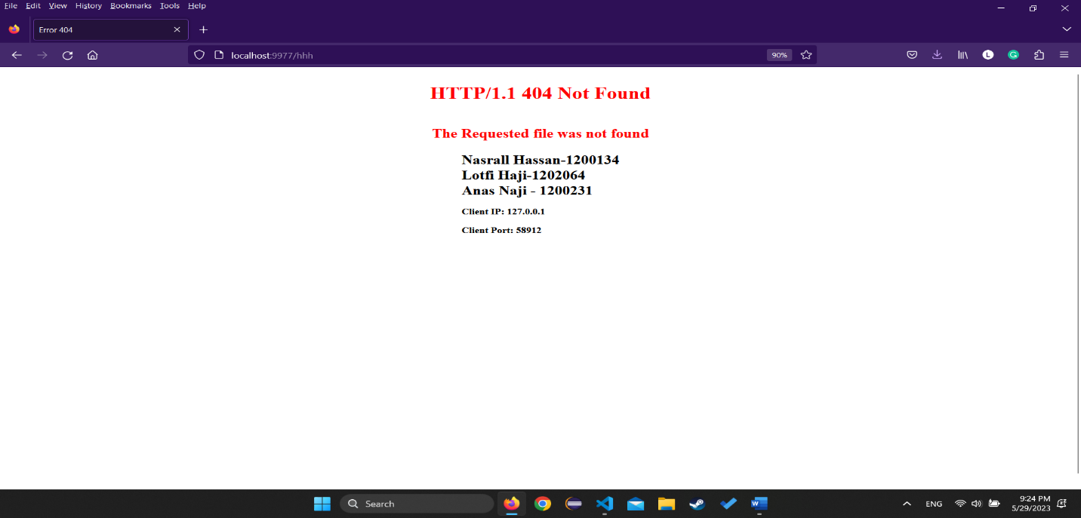

Figure ‎0‑31Error page

And here is the terminal of that page:

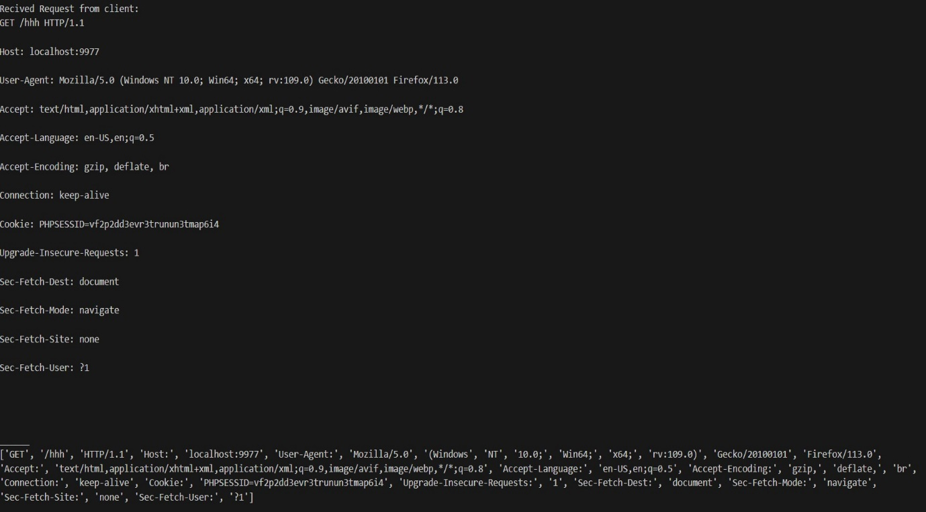

Figure ‎0‑32 error page terminal

# Conclusion:

To conclude, we can say that throughout this Project we have been able to understand the fundamental of network protocols inside the transportation layer, and we were able to improve our knowledge about different types of protocols, such as TCP and UDP in addition different commands such as ping, nslookup and much more which have been discussed throughout our document, not to forget increasing our fundamental knowledge in html and CSS, and learning more about how those files travel the internet and how the HTTP request and responses are introduced and how they get handled by the browsers, not to forget about broadcasting using UDP.